# AWS Introduction

## What is AWS?

AWS stands for Amazon Web Services which uses distributed IT infrastructure to provide different IT resources on demand.

The AWS service is provided by the Amazon that uses distributed IT infrastructure to provide different IT resources available on demand. It provides different services such as infrastructure as a service (IaaS), platform as a service (PaaS) and packaged software as a service (SaaS).

Amazon launched AWS, a cloud computing platform to allow the different organizations to take advantage of reliable IT infrastructure

## Uses of AWS

A media company can use the AWS to provide different types of content such as ebox or audio files to the worldwide files.

## Pay-As-You-Go

Based on the concept of Pay-As-You-Go, AWS provides the services to the customers.

AWS provides services to customers when required without any prior commitment or upfront investment. Pay-As-You-Go enables the customers to procure services from AWS.

* Computing
* Programming models
* Database storage
* Networking

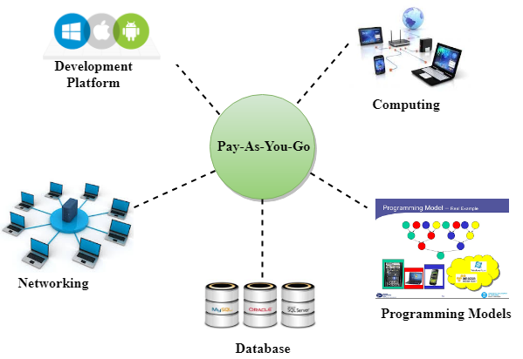

## Advantages of AWS

* Flexibility
* Cost-effectiveness
* Scalability/Elasticity
* Security

# AWS Global Infrastructure

* AWS is a cloud computing platform which is globally available.
* Global infrastructure is a region around the world in which AWS is based
* The AWS Cloud operates in over 77 Availability Zones within over 24 geographic Regions around the world.
* AWS global infrastructure is a combination of regions and availability zones.

## Availability zone as a Data Centre

An availability zone is a facility that can be somewhere in a country or in a city. Inside this facility, i.e., Data Centre, we can have multiple servers, switches, load balancing, firewalls. The things which interact with the cloud sits inside the data centres.

## Region

* A region is a geographical area worldwide where AWS hosts its data centers. Each region consists of 2 more availability zones.
* A region is a collection of data centres which are completely isolated from other regions.
* A region consists of more than two availability zones connected to each other through links.
* Availability zones are connected through redundant and isolated metro fibers.
* AWS regions are independent from one another meaning that our data is not replicated from one region to another without our consent and authorization.
* Inside every Region is a cluster of Availability Zones (AZ). An AZ consists of one or more data centres with redundant power, networking, and connectivity.

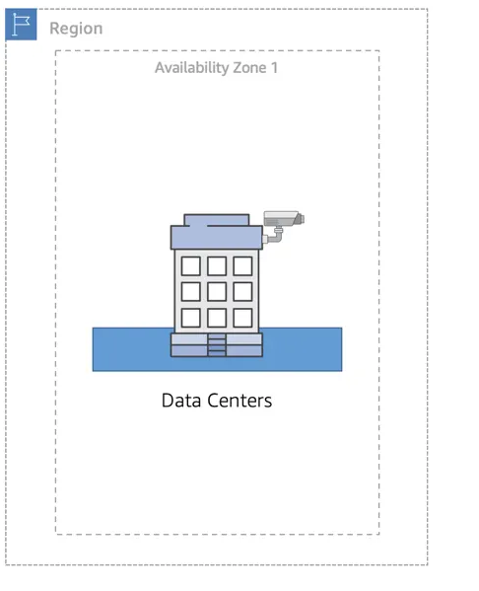

## Maintain Resiliency

* To keep customers satisfied, you need to maintain high availability and resiliency. A well-known best practice for cloud architecture is to use Region-scoped, managed services. These services come with availability and resiliency built in.
* When that is not possible, make sure the workload is replicated across multiple AZs. At a minimum, you should use two AZs. If one entire AZ fails, your application will have infrastructure up and running in at least a second AZ to take over the traffic.

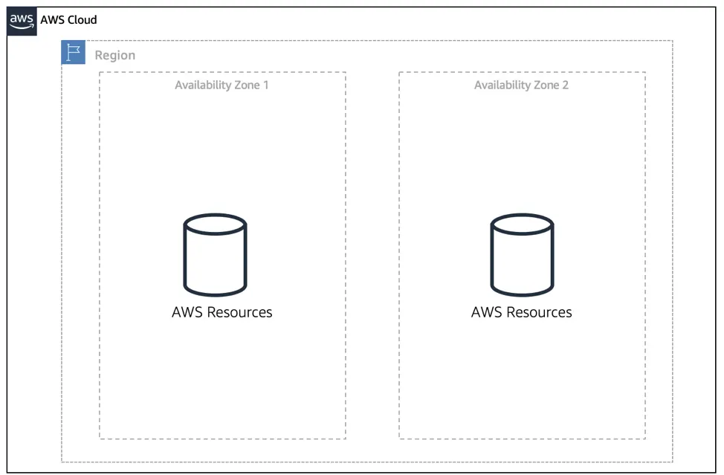

# IAM (Identity Access Management)